**The New Paradigm Powering Global Food Security and Supply Chain**

End to end agric-tech platform enabling farmers to sell to buyer globally

Expanding financial options for farmers globally

Better management of inventory based on historical data

Increased efficiency with reduction in waste and better transportation practices

Transforming the way farmers think and succeed

|  |  |
| --- | --- |
| Token Sale | Watch video |

|  |  |  |  |  |  |  |
| --- | --- | --- | --- | --- | --- | --- |
| F | IN | T | M | T | D | IN |

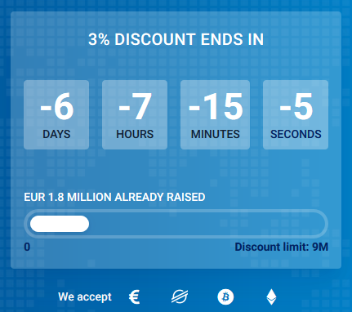

BLOG

|  |  |  |  |  |  |
| --- | --- | --- | --- | --- | --- |
|  |  |  |  |  |  |

**What is Agrichainx?**

Agrichainx is a blockchain and internet of things ecosystem that simplifies and streamlines agricultural commodities trade, supply chain, value chain, food security, international collaboration, contracting, logistics, financing and payments for all stakeholder.

**AGRICHAINX ECOSYSTEM**

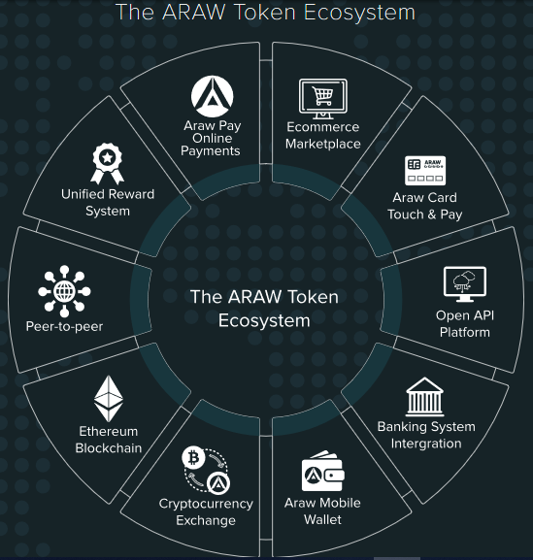

The Agrichainx Ecosystem

**AgricTrade**

AgricTrade is an online marketplace connecting agri trade networks from farmers to buyers. It create a direct business tie-ups between farmers, transporters, cold storage providers, retailers, and even consumers.

**AgricStorage**

AgricStorage is Agric’s network of cold storage facilities across Nigeria and Africa partnered with local farmers and retailers for preserving their crop stocks.

**AgricFinance**

AgricFinance is a micro-financing scheme for small farmers. It will make grassroots financing such as lending, crowdfarming available and enhance financial support to farmers. AgricFinance will also enable farm insurance and farmer’s pension.

**AgriChain**

AgriChain is a supply chain architecture that tracks and monitors crops right from the time they are harvested to the time they are received by retailers/consumers.

**AgricData**

Farmer’s digital form of identification will be created and stored in the IPFS. This digital identity will be used for verification and validation of the smart farming contracts.

**AgriContracts**

Agrichainx transpose farming contracts to smart farming contracts in a distributed database. And it will include smart contracts between various service providers and agriculture stakeholders.

**AgricHubs**

AgricHub is an enterprise hub that facilitates regional activities taking place inside the agrichainx ecosystem. It is a central unit that looks after the interests of farmers and retailers by up a smart farming contract.

**Logostics**

Our partnership with reputable Logistic companies will see us exploring new possibilities for blockchain-powered supply chain management.

**Precision farming**

Agrichainx IoT- based smart farming system is built for monitoring the crop field with the help of sensors (light, humidity, temperature, soil moisture, etc.) and automating the irrigation system. And this oversee the farm conditions from any location.

**Agricoin**

Agricoin are agrichaincoin’s institutionalized blockchain-based tokens that can be used as a form of payment settlement between participants.

**PROBLEM**

The production, transformation and distribution of food and agricultural products are generally accepted as routine aspects of daily life around the world. Therefore, such activities have rarely been addressed within the realm of ethics.Centralized trade barriers and structures have reduced trade transactions, indirectly limited access to secure food, created price manipulation by middlemen and intermediaries and these has painted the agricultural product and commodity market as not risk worthy.

|  |  |  |  |
| --- | --- | --- | --- |
| **Poor Access to Open Market**  Farmers are forced to sell their produce at throw away prices to traders as soon as they harvest. They do not have access to information and not connected to a pool of buyers. | **Poor Data Management**  Despite the rapidly expanding adoption of agricultural technologies, post-harvest operations are impaired by systems that only manage a small part of the supply chain | **Lack of Trust and Visibility**  The complexity and barrier in global supply chain make it harder to follow the path of agricultural commodity to market. | **Traceability**  More consumers worldwide are demanding information as they have the right to know where their food has come from, how it was transported and what practices were used in its production. |
| **Lack of Access to Advance Farming**  There is constant loss of crops due to lack smart farming system for monitoring crop field with the help of sensors to have soil data such as (light, humidity, temperature, soil moisture, etc.) and to automate the irrigation system. | **Poor Financial Services**  Lack of access to efficient financial services is depriving farmers of the possibilities to grow their businesses or convert their ideas into new profitable projects. | **Slow Cash Settlements**    The traditional financial and verification setups offer a major drawback in cash settlement which births transaction bottlenecks. | **Lack of Information**  Most farmers are operating at just 40% of their potential capacity because of poor access to information and this affects farmer’s ability to plan and harvest more effectively and gain access to market. |

**SOLUTION**

An Enterprise-driven blockchain ecosystem for agriculture sector that would allow farmers to sell their crops directly to retailers, exporters/importers, super markets chain, hotel industries, consumers, etc., without relying on the traditional multi-level distribution structure. Each farmer on the platform is registered using biometric verification, and get allotted with a unique meta ID. This meta information in a long run provides businesses and consumers a complete description of farmer’s land and the quality of crops they harvest like organic or non-organic, etc. They will also be able to preserve their crops using the facilities of brick-and mortar cold storage and warehouse network.

|  |  |  |  |
| --- | --- | --- | --- |
| **Marketplace**  An efficient and robust digital marketplace that allow buyers and growers to connect directly to consumers, increasing the amount of profits that go to the farmers. | **Supply chain tracking and automation**  Agrichainx records every stage of growth for a registered crop, from seeding to flowering, to selling to consumers and wholesalers, which creates transparency about the produce for the buyer or consumer. | **Information and data visibility**  The digital ledger solution provides immutable information providing trust and transparency  throughout the supply chain. | **Recordkeeping and proof of origin**  As commodities move along the supply chain, proof of origin can be established and also proof of income all recorded all in digital ledger. |
| **Smart Farming**  Smart farm allows farmers to capture data in real-time, combined with IoT.  And these Data helps in monitoring crop growth, harvesting, and expected yields. | **Expand financial options for farmers**  Farmers can use the verification for funding or purchasing crop. And smart lending and insurance options. | **Immediate payment on delivery**  Agrichainx will enable real-time payment on delivery and improve settlement process for farmers, Farmers get paid immediately without delay | **Smart contracting**  Agrichainx provides seamless contract solutions between farmers, brokers, buyers and logistics providers. |

**How Agrichainx Blockchain Ecosystem Works**

Agrichainx Blockchain Ecosystem has been designed to be self-expanding and effortlessly scalable to support all types of small holder farming, ranging from agricultural and commodity trade, supply and value, smart agriculture, agricultural funding, logistics to global commercial trade, with market size of up to 20 trillion USD.

|  |  |  |
| --- | --- | --- |
| 1  **Service Providers**  Contribute to the development of the core elements of the Ecosystem.  Farmers  Growers  Consumers  Logistics companies  Cooperative  Supermarket  Exchanges | C:\Users\PROVENTIO 03\Desktop\CaptureNB.PNG | 2  **Core Elements**  Used by the Ecosystem participants as building blocks for the development of innovative Blockchain solutions.  Fiat & crypto money gateways  Automating Purchase Process  Secure Supply Chain  Faster Transaction Flow  Detection & Prevention of Frauds  Ensuring Integral Traceability  Streamlining Internal Documents |
| 4  **Ecosystem Users**  Both business and private users reap the following benefits to improve performance:  Global reach  Food Security and transparency Reduced costs  Speed of transactions Convenience  Supply Chain Efficiency | 3  **Blockchain Solutions**  Every solution developed by Agrichainx Ecosystem run smoothly to integrates some or all of the core elements of the Ecosystem to boost business processes.  Solutions for merchants, logistics, crypto industry, and others.  AgricTrade  AgricFinance  AgricStorage  AgricData  AgricHub  Logistics  Smart Farming  Agricontract |

**Don’t miss our blog videos!**

|  |  |
| --- | --- |
|  |  |
|  |
|  |

**EVENTS AND PHOTO GALLERY**

|  |  |  |  |  |
| --- | --- | --- | --- | --- |
|  |  |  |  |  |

**Agrichainx Token Details**

The Agrichainx Token is considered as the most valuable asset on the network. The token will be referred to as Agricoin “AGN” and will be issued to serve as fuel for the ecosystem and as a form of exchanging on the platform to give incentives to users, to encourage trade and to build a trust less platform to facilitate market activities.

|  |  |  |  |  |  |  |  |
| --- | --- | --- | --- | --- | --- | --- | --- |
| Symbol AGN | TYPE ERC-20 | DECIMAL 18 | TOKEN PRICE  1 AGN = $0.5 | Accepted Currencies ETH, BTC, NGN | Soft Cap $5,000,000 | Hard Cap $50,000,000 | TOTAL TOKENS 200,000,000 AGN |

|  |  |
| --- | --- |
| https://prepayway.com/img/svg/token/demand-key-factors-illustration.png | Agrichainx Token Demand Key Factors  Demand for the services delivered by Agrichainx Blockchain Ecosystem.  Development of a proprietary blockchain.  Growing volume of transactions concluded in Agrichainx tokens.  Crowdfarming and P2P Lending  Insurance coverage and FarmersPension  Expansion of Agrichainx Blockchain Ecosystem by attracting businesses from multiple agric industries and regions. |

**Token Allocation Forecast**

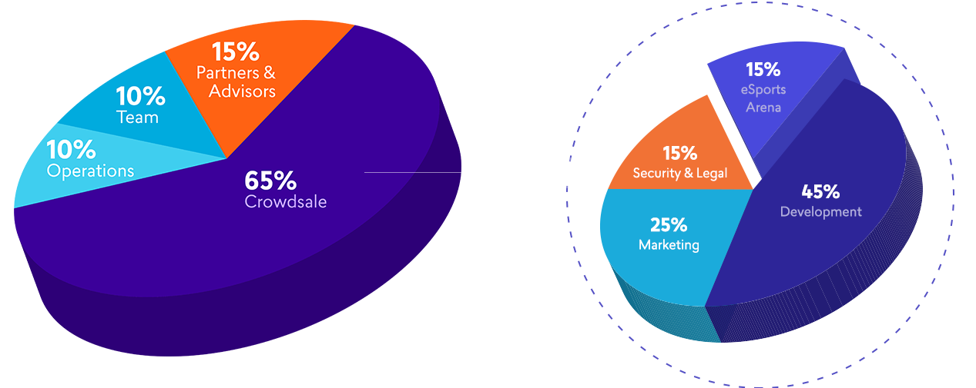

**Distribution Funding Allocation**

**TOKEN DISTRIBUTION**

Private Sale 15,000,000

Pre-sale Tokens 30,000,000

Main Sale 75,000,000

Team, Partners/Advisors/ Contractors 3,000,000

Stakeholders 16,000,000

Founders Team 5,000,000

Developers/Marketers 2,000,000

Airdrop and Bounty 14,000,000

Reserved Funds 40,000,000

**Funds Allocation**

Development 50 %

Community / CSR 10 %

Branding, Promotion and Marketing 10 %

Administration 15%

Reserve 10 %

Security and Legal Expenses 5 %

**Roadmap**

**Q4: 2018**

Idea Conceptualized

Research and Development

Proving the concept can work

Strategic Plan

**Q1: 2019**

Team Assemble

Whitepaper Development

Awareness Creation and consultation

Preparation for Stake Offering

**Q2: 2019**

Agrichainx Website Launched

Marketing and Initial Stake Offering Begins

Private and Presale Begins

**Q3: 2019**

Main Sale Begins

Launch of Agrichainx ERC20 P2P smart contracts

Internal Exchange Development

**Q4: 2019**

Partnership with major stakeholders.

Alliance with agricultural products processing companies.

Exchange Listing

**Q1: 2020**

Launch of Agrichainx Marketplace

Agrichainx Center Platform development and beta testing begins

**Q2: 2020**

AGNwallet

Launched of Agricfinance

Local Agent Center Launched

**Q3: 2020**

Smart Agric Farming functionality Beta Testing.

AgricCard-Touch and Pay Mobile Solution

AgricPay

**Q4: 2020**

Farmers Pension launched

Launch of Agrichainx mobile app on Google and Apple stores.

IOT Sensor and Monitoring Satellite Deployment.

**Q1: 2021**

Drones acquired for farming and tracking functionality.

Development, launch, and trials of AI and data capturing system prototype.

**Q2: 2021**

Deployment of POC Sensors and initial Data Baseline creation.

Initial data gathering, data scientists start creating control-guide structures. AgricStorage

**Q3: 2021**

Expansion to new markets and global sales.

**MEET THE TEAM**

The Agrichainx team is uniquely positioned to take on this challenge. Our team is comprised of experienced entrepreneurs who bring in-depth knowhow across the dimensions of business, IoT technology, AI, Big Data, software, blockchain, and the agriculture industry. The Agrichainx network, team and advisors shares the same spirit in which cryptocurrencies and tokens were originally envisioned: transparency, fairness, accessibility, and innovation.

**Our Global Partner Network**

|  |  |  |  |  |  |  |  |  |  |  |  |  |  |  |
| --- | --- | --- | --- | --- | --- | --- | --- | --- | --- | --- | --- | --- | --- | --- |
|  |  |  |  |  |  |  |  |  |  |  |  |  |  |  |
|  |  |  |  |  |  |  |  |  |  |  |  |  |  |  |
|  |  |  |  |  |  |  |  |  |  |  |  |  |  |  |
|  |  |  |  |  |  |  |  |  |  |  |  |  |  |  |
|  |  |  |  |  |  |  |  |  |  |  |  |  |  |  |

**Agrichainx in Media**

|  |  |  |  |  |  |  |  |  |  |  |  |  |  |  |
| --- | --- | --- | --- | --- | --- | --- | --- | --- | --- | --- | --- | --- | --- | --- |
|  |  |  |  |  |  |  |  |  |  |  |  |  |  |  |
|  |  |  |  |  |  |  |  |  |  |  |  |  |  |  |
|  |  |  |  |  |  |  |  |  |  |  |  |  |  |  |
|  |  |  |  |  |  |  |  |  |  |  |  |  |  |  |
|  |  |  |  |  |  |  |  |  |  |  |  |  |  |  |

**ABOUT US**

**About Agrichainx**

The idea for agrichainx was born in Africa, where there is high potential for agriculture. And tech, blockchain, banking, international business, and legal professionals came together to revolutionize business processes. Coming from a plethora of professional backgrounds, our diversely experienced team is dedicated to creating an ecosystem that facilitates secure, swift, transparent commercial transactions, all while reducing transaction costs.

**Our Goals**

|  |  |  |  |  |
| --- | --- | --- | --- | --- |
| **Global Market Linkage**  Connecting agri trade networks from farmer to end buyer and getting them online. | **Disintermediation**  We aim to reduce the need for trusted intermediaries while increasing security, removing time and cost bottlenecks. | **Increased Speed of Transactions**  By speeding up transactions we aim to increase the velocity of money, which will increase cash flow and capital investments. | **Expand financial options for farmers**  Provides quicker access to funding resources and make farmers financially inclusive. | **Global Reach**  Our goal is to become the standard for seamless digital commercial transactions for agriculture on a global scale and across borders. |

**Our Approach**

|  |  |  |  |
| --- | --- | --- | --- |
| **Pragmatic**  We are adapting the blockchain technology to eliminate inefficiencies that plague the agricultural industry, one step at a time. | **Focused**  We are focusing our skills and competence on restructuring business processes to reduce costs, stamp out fraud, speed up transactions, and internationalize markets. | **Reliable**  Reliability and professionalism is at the core of our services. We are incorporated in Nigeria to take full advantage of the stable political and financial climate and the innovation-friendly regulatory framework. | **Adoption**  Targeted and specialist resource dedicated to merchant on-boarding, education and support to ensure mainstream adoption. |

**Our Values**

|  |  |  |
| --- | --- | --- |
| **Customer Satisfaction**  Customer satisfaction is our prime priority. We are trustworthy, committed, and flexible. We carefully tailor solutions to customer needs. | **Trust**  Trust is at the heart of our relationship with people and businesses that we work with. We set our commitment to data protection and security at the highest level. | **Integrity**  Integrity is the foundation of our uncompromising standard of honesty, transparency, and openness in every action. |

**Team**

**Regional Representatives**

Our regional representatives are experienced professionals with a keen understanding of the markets in which they operate. They help us shape our services according to the local markets' needs and constraints.

**Advisors**

Together with our advisors, acknowledged leaders in their fields, we are developing Agrichainx Blockchain Ecosystem based on three main pillars: commercial transactions, improving farmers well beingl, and technology.

**Solutions**

**Step into the future of agricultural trade**

Agrichainx provides a platform for the commercial trade of agricultural produce where farmers, sellers and buyers can conduct the entire trade process in a secure and transparent ecosystem.

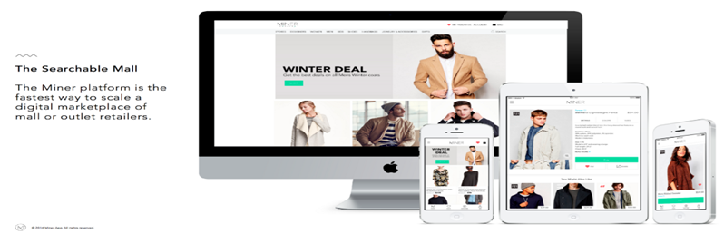

|  |  |  |
| --- | --- | --- |
| C:\Users\PROVENTIO 03\Desktop\Capture1.PNG | C:\Users\PROVENTIO 03\Desktop\Capture2.PNG |  |
| **Sellers Of agricultural produce**  Dedicated farmers, agricultural cooperatives, and other suppliers of agricultural produce save money and earn more by digitizing their business.  **I am a seller** | **Buyers**  **Of agricultural produce**  Dedicated retailers, manufacturers, distributors, and other commercial buyers transact directly with their sellers on a platform that creates a transparent and trackable trade process.  I am a buyer |

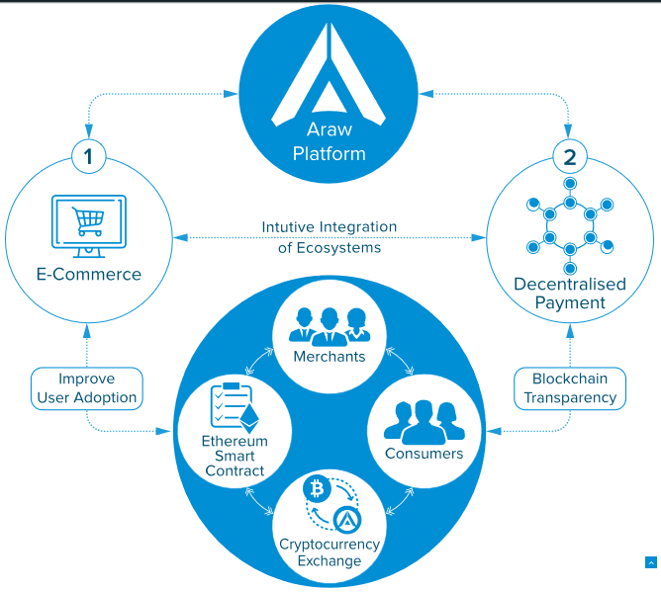

Members create business profiles on the platform

Every profile is verified to create a trusted, transparent, safe and secure environment.

Through their profiles, users can access unique business tools including real-time management of daily orders, quotes, invoices, and payments.

|  |  |
| --- | --- |
| C:\Users\PROVENTIO 03\Desktop\Capturen.PNG | Users create their digital ecosystems  The ecosystems streamline communication between business networks with common characteristics.  Within their ecosystems, users can interact with their network in real-time, share data, send notifications, and transact with multiple entities in one go. |

|  |  |
| --- | --- |
| Sellers create their digital inventories  Every digital inventory includes key product details like certifications, varieties, weight, and packing options.  The inventories can be shared with their buyers to provide full transparency of product availability. | C:\Users\PROVENTIO 03\Desktop\Capturem.PNG |

|  |  |
| --- | --- |
| C:\Users\PROVENTIO 03\Desktop\Capturex.PNG | Buyers and sellers transact with each other directly  The digital platform enables a dependable process from the first quote request until the transaction is complete for the purchase and sale of agricultural produce.  Every interaction is digital to enable the transacting parties to track every step of the trade process. |

|  |
| --- |
| **Powered by Blockchain Technology**  The Agrichainx ecosystem application records trade interactions and allows to share verified and immutable trade-related information with other trade partners and other service providers. |
|  |

**Agricfinance**

AgricFinance is a micro-financing scheme for smallholder farmers. It will make grassroots financing such as lending, crowdfarming available and enhance financial support to farmers. AgricFinance will also enable farm insurance and farmers’ pension. Provides quicker access to funding resources and make farmers financially inclusive;

**Peer-To-Peer Lending**

Our Blockchain-based P2P platform connects lenders with profitable small farming communities around the globe. And is a transnational peer-to-peer crowdlending platform.We globally connect investors (lenders) with small unbanked producers and smallholders farmers (borrowers).

**AgricCSA** (Community-supported agriculture) operations bring together members of a community, who pledge to support a farming operation financially in return for fruits, vegetables, or whatever else a farm may produce. And this include the tokenizing of shares in community farms for easier sale and the ability to reward volunteer labor directly with shares, and minimizing food waste through sensor-based crop quality tracking.

**Agricfinance at a Glance**

|  |  |  |  |
| --- | --- | --- | --- |
| **Positive Impact Projects Only**  Because they generate Value, as opposed to loans for consumption that generate Debt. | **Real P2P**  Money goes straight from lenders to borrowers via Smart Contracts, without intermediaries, not even ourselves. | **Access to the Unbanked**  Especially the agricultural sector which represents a significant part of 2 billion unbanked people. | **Farmers’ Pension Scheme (FPS)**  Provides pension benefits to small farmers for an assured income, a secured retirement in their old age. |
| **Crowdfarming**  Agrichainx enables like-minded farmers to agree on lending arrangements driving down the cost of accessing agricultural financial products. | **AgricCSA (Community-supported agriculture)**  Connects members of a community, who pledge to support a farming operation financially in return for farm produce. | **Know-How in Project Selection**  As producers, buyers and financial intermediaries of agricultural production we have strong field contacts and first-hand experience. | **Insurance**  By gaining access to live, accurate, immutable data, ins'urance companies are able to effectively assess claims, offer tailored products to customers. |

s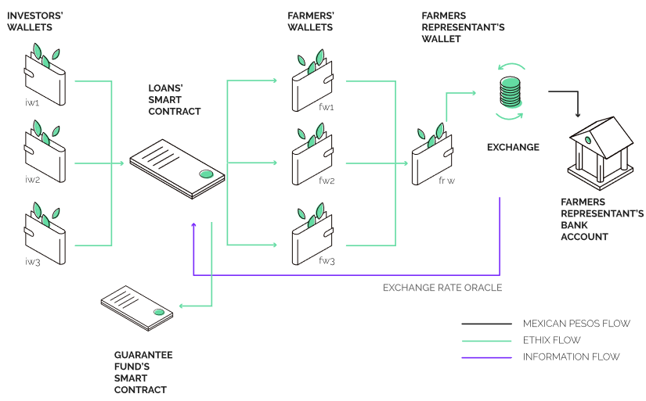

**Crowdfarming**

We are a premier crowd funding platform using technology to transform African agriculture by promoting shareholding farming and addressing value chain gaps. Our crowdfarming platform enables:

1. Investors, both large and small to jointly invest in crowd funded large scale farming projects,

2. Land owners to lease their land for our crowd farming projects,

3. Small holder farmers to join our out growers to supplement our supply and

4. Buyers to have a reliable source of high quality farm produce.

**HOW IT WORKS**

|  |  |  |
| --- | --- | --- |
| Choose farm to invest in  Here’s how you can become an impact maker and be part of the mission to improve our farmers’ lives. | Farm successfully funded  Sign-up and register to be able to view and invest in the selection of farms curated for this cycle. | Empower farmers and  improve productivity  Funds and resources will then be utilized to improve production. We manage the funds for the farmer making sure it is used in the right way ensuring you get a good return on your investment. |
| Fruits of your investment  After the harvest and once the produce has been sold, the capital will return to the investor’s wallet together with the profit shared. | Transparency & Security  All documentation for your investment is through a smart contract (secured via blockchain). The contract is fully transparent to investors outlining returns, timeframes, use of funds, and other key elements. | All parties have online access to this contract. Funds/Returns will be deposited directly into investor wallet (in £/€/$) and can be transferred to any bank account worldwide or reinvested in other projects. |

**Agrichainx Payment Gateway**

The payment options currently available for ordinary farmers are almost unrealistic. The administrative process of opening an account is a complicated and time -consuming option for ordinary farmers whose life relies on farming. As a result, vast mass affluent is deprived of necessary banking solutions. Furthermore, to all those who can access banking are deprived of the lion share of the revenue they have generated as almost 50% of the share is taken by the middlemen.

Agrichainx will address these issues by providing a decentralised payment gateway; the payment gateway will ensure peer-to-peer transfer and value storage between farmers and consumers.

**AgricPay**

AgricPay is a 2-level crypto payments processing service. As a payment gateway, AgricPay will have the following features:

• Creating mobile multi-sig crypto wallets;

• Safe crypto assets storage;

• Free and instant payments within the platform;

• The option of issuing and receiving bills/invoices

• buying and selling cryptocurrencies in online mode;

• Recurring payments;

• Binding to bank accounts and cards;

• Integration with third-party software (for restaurants, accounting, inventory control, etc.).

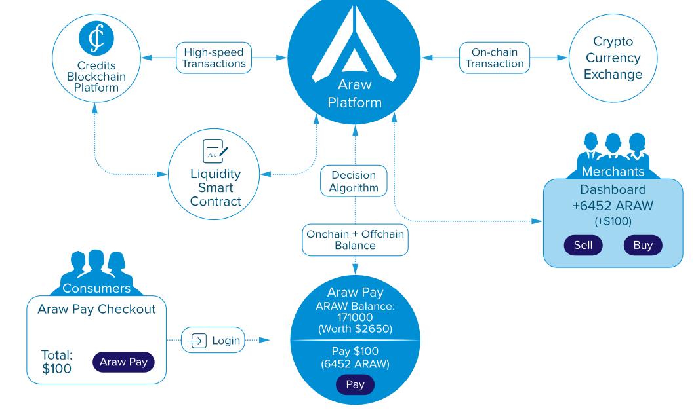

**AGNWallet**

AGNWallet is a smart multi-currency wallet. You can create both as a unique wallet for your smartphone and synchronize it with other devices (PC, tablet, smart watch, etc.)

Functional Agrichainx ecosystem wallet will allow users to:

• To ореn multi-currency accounts and crypto-currencies.

• To issue invoices and pay bills.

• To use only one or both of wallet levels.

• To make instant and free transactions.

• To have access to exchange operations and conversion of fiat and cryptocurrencies.

• To use the integrated messenger

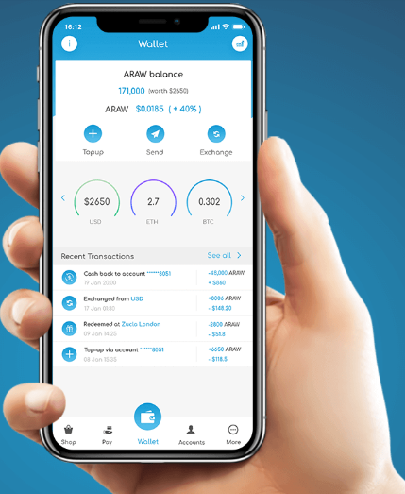

**AgricCard - Touch & Pay**

AgricCard - Touch & Pay card aims to enable customers to make micropayments with their AGN tokens at shops, supermarkets and day-to-day online shopping.

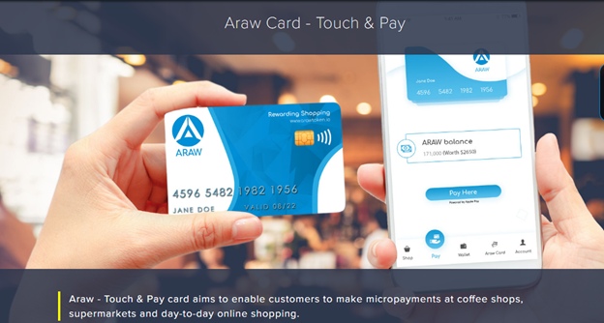

**AgricStorage** supports smallholder farmers, agricultural service providers and development workers by providing them with storage facilities across board for sustainable agriculture. Harvesting, conditioning and storing crops correctly maintain the value of the crop and maximise marketing opportunities.

|  |  |  |  |
| --- | --- | --- | --- |
| Agrichainx’s quality assurance department works closely with our own stores as well as third party stores to monitor storage conditions and recommend remedial action as necessary. | Expert management of grain quality during storage ensures grain supplied to consumers meets contract specifications and complies with food safety laws. | Cleaning and drying grain is often required at harvest, particularly during wet seasons. This reduces the likelihood of rejections leading to claims, additional haulage and redirection costs. | Growers should consider whether to store unpriced grain in order to capitalise on market gains. This is particularly helpful at harvest when there may be an advantage in avoiding pricing at a typically discounted time of the marketing year. |
|  |  |  |  |

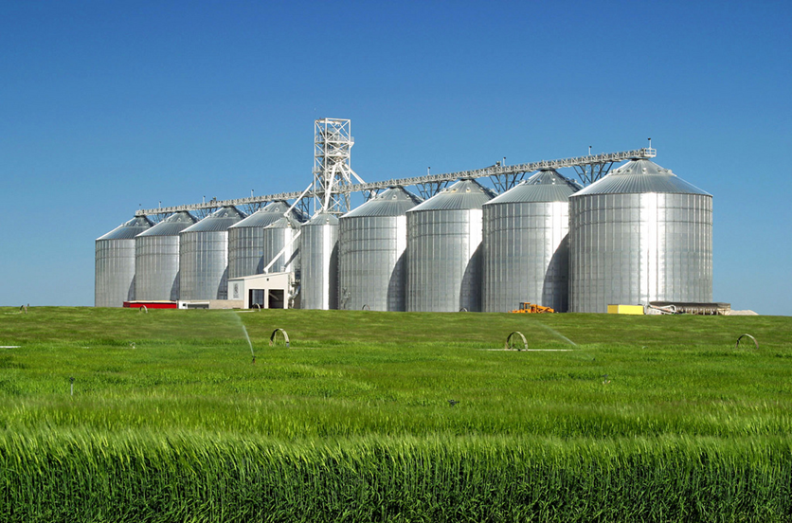

**Agricdata**

Agricdata integration aims to reduce costs and times of data management, in order to support farmers in making right decisions on field and to provide the necessary documentation.

All data coming from fields, weather, treatments, water resources, IoT analyses and more, will be automatically collected and organized into the platform, then tracked by the blockchain code from the origin of the product to its transformation, up to the final retailer.

We provide solutions that solve complex technology challenges across the entire agricultural supply chain. Our solutions enable farmers to allocate scarce resources to produce a safe, reliable food supply in a profitable and environmentally sustainable manner.

|  |  |  |  |
| --- | --- | --- | --- |
| **Measure**  Measure your crop with unmatched precision. We provide forecasts up to three months prior to harvest. Our software technology analyzes fruit quantity, density and size to help optimize your farming. | **Evaluate**  Evaluate attributes such as maturity, defects, diseases, and pests. Select customized qualitative attributes for inclusion in field scans. This allows you to better allocate resources. | **Manage**  Manage your ranch and your business with accurate and comprehensive intelligence. Maximize revenue by remedying low yield areas. Minimize costs associated with future contract settlements, labor, chemicals and crop insurance. | **Save Time**  Share farm data across all devices in real time, eliminating dual entry and USB hassles. |
| **Improve Efficiency**  **Automate critical workflows to make smart in-season decisions that improve the bottom line.** | **Reduce Human Error**  **Improve field record integrity and streamline data entry with software that syncs automatically.** | **Drive Profits**  **Track your cost per acre so you can make intelligent decisions throughout the growing season.** |  |

**AgricHubs**

AgricHub is an enterprise hub that facilitates regional activities taking place inside the agrichaincoin ecosystem. It is a central unit that looks after the interests of farmers and retailers by taking over the complex responsibilities like setting up a smart farming contract. Realizing that blockchain-based services are overly complex for non-technical users, AgricHub will ensure that the farmers’ interaction with an advanced agrichainx is done using methods that are known to them. For instance, bio-verification or value transfers using thumb prints.

The agrichub provides a high profile, professional home for agriculture organizations and related companies.

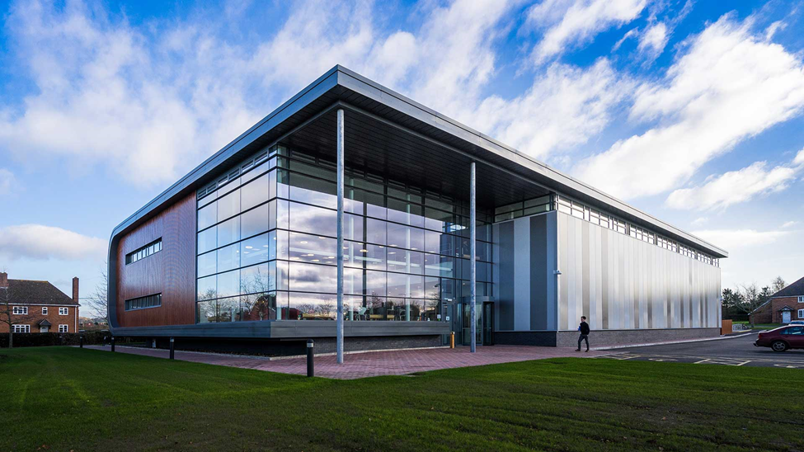

**AgriChain**

AgriChain is a supply chain architecture that tracks and monitors crops right from the time they are harvested to the time they are received by retailers/consumers.

Agrichain will supports farmers in the traceability and in the certification of agricultural products by using the Blockchain technology and Smart Contracts.

This security system allows to make safe and automatic all the transactions along the supply chain, increasing the high quality production, improving the environmental sustainability and guaranteeing transparency and safety to the final consumer.

|  |  |  |
| --- | --- | --- |
| TRACEABILITY WITH BLOCKCHAIN  The Blockchain allows to verify in a transparent manner the digital history of products along the supply chain, from farmers to final consumers, guaranteeing food safety and quality against the food market falsification. | CERTIFICATION  Certificate your activities and share all the needed information with your clients or certification providers in a centralized and easily way, reducing costs and time. | MOBILE ACCESSIBILITY  Free to work and manage your data everytime and everywhere in real time, using mobile interfaces and the integration of ChatBot App. |
| PRODUCT SPECIFICATION  Guarantee the techniques and the adjustment to the production policy rules, for the DOCG products and to those intended for international markets. | LEGAL COMPLIANCE  Meet the legal needs imposed by the European regulation to farms and guarantee the production chain. Always updated with the law directives. | OPEN DATA INTEGRATOR  An automatic system to integrate information coming directly from invoices, receipts or other agri-food chain data devices without manual data uploading. |

**Logostics**

Our partnership with reputable Logistic companies will see us exploring new possibilities for blockchain-powered supply chain management.

We offer multimodal transportation management capabilities and agricultural logistics solutions for a variety of agricultural goods, including cocoa beans, maize, potatoes, tomatoes, avocadoes, eggs, meat products, a variety of fruit, wheat, sunflower, sorghum, soya beans and peanuts, as well as lime and fertilisers.

We are also deploying ​innovative Smart Logistics solution in addressing the quality, quantity, sustainability, and cost effectiveness of agricultural production. Smart Logistics monitors the temperature around the material and automatically reports any deviations from set thresholds. The deviation provides not only the temperature but the duration and the locations.

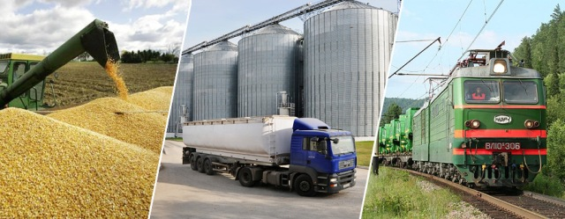

**How it works**

|  |  |  |
| --- | --- | --- |
| **CONDITION MONITORING**  Smart Logistics allows food producers, packagers, and shippers to monitor the condition of food shipments to control temperature and guard against spoilage, which is critical for both fresh and frozen shipments of produce, meats, and seafood | **REUSABLE CONTAINERS MONITORING**  Smart Logistics solution enables companies to monitor a range of information about their essential equipment, such as returnable/reusable containers. This includes location of containers, the temperature, the process workflow, and cycle time. | **FOOD SHIPMENT MONITORING**  Trucks will typically start and stop at the same location while doing multiple pickups during the day. Smart Logistics automatically displays the exact location of trucks and the nearest truck to the pickup location. |
| **http://bell.one/catalog/view/theme/bellOne/image/IoT/agriculture/condition.jpg** | **http://bell.one/catalog/view/theme/bellOne/image/IoT/agriculture/reusable.jpg** | **http://bell.one/catalog/view/theme/bellOne/image/IoT/agriculture/food.jpg** |

**Precision farming**

Agrichainx IoT- based smart farming system is built for monitoring the crop field with the help of sensors (light, humidity, temperature, soil moisture, etc.) and automating the irrigation system. And this oversee the farm conditions from any location. Agrichainx uses a special technology for these operation called smart agric.

**Transforming the way farmers think and succeed...**

**FEATURES**

|  |  |  |  |
| --- | --- | --- | --- |
| **Plant population**  Using our AI2 technology, we can report plant population to farmers, regardless of growth stage of the crop. We can detect the position of each plant to calculate plant emergence and also calculate canopy cover, plant height, and much more. | **Weeds early detection**  Smart agric can detect when a weed emerges in the field and constitutes a potential threat to the yield and then classifies it. This type of alert allows us to target specific weeds by species and can help to create tailored herbicide solutions. | **Field Health**  Smart agric can calculate the amounts of nutrients in vegetation, the water content in the soil, plant temperature and much more. We help farmers keep track of the field’s health, detect subtle changes and act before they affect their crops. | **Insects and Disease treatment**  Smart agric can identify and categorize the top relevant diseases for prevalent crops in our areas of operation. It can also detect physical damage to the foliage caused by known insects and pests, thus providing an alert mechanism to detect adverse field conditions. |
| **Actionable Insights**  For producers and service providers, they need to know how to act on threat data. The real power of image data comes from actionability. Converting image data into field events such as scouting and sampling has never been easier with our integrated platform and mobile app workflow. | **Ultimate ag-imagery solutions**  Smart Agric offers the ultimate ag imaging based on its proprietary technologies UHR & AI2 that offer a unique synergy.  The UHR prioritize stressed areas that need more attention. | **All information combined**  Smart agric not only provides image capture capabilities but feeds all imagery into it’s full analytics platform that farmers, ag retailers, seed and chemical input manufacturers can license to provide and implement well informed crop treatment recommendations. | **Task management**  Instead of calendar, whiteboards, notes and paper schedules, Smart agric gives your team an easy to use task manager that is integrated in your workflow. Designate tasks and activities to any field, categorize tasks and avoid conflicting operations, assign to any employee. |
| **On-demand imagery**  To deliver remote sensing at scale, we monitor the entire sky over the farmlands with a system called FOCS which automates flight planning and route optimization for a network of 3rd party pilots. | **Smart field scouting**  Smart agric app is the best tool for data collection and integrated threat management in the field. Smart agric detects problematic hot spots and prioritizes them for further investigation. | **Growth problems**  Our platform can analyze images, taken in proximity to sowing time, in order to detect growth irregularities while there is still time to resow or to correct the underlying problem. | **Anywhere, anytime**  Smart agric dashboard is accessible from any computer. It is easy to “monitor in a glance”. Using the dashboard the farm manager, agronomists and consultants can see history and all relevant data as layers on our GIS. |
| **24/7 Customer service and team of agronomists**  As part of the services, we provide 24/7 customer support, with offices spread worldwide, and in each location we have teams of local agronomists and consultants, specialising on the crops and soil of each area. | **Air scouting**  Smart agric created the multi-layer air scouting. Users can detect a problem by using satellite images, and select specific fields in the need of UHR whole field 8cm imagery, and from there detect specific areas of the field which need to be photographed by AI2 planes. | **Crop-specific management plans**  we not only provide the ultimate ag-imagery solution and the ability to gather data about fields, but also assist producers and service providers to plan the best ROI plan for their specific crops. Producers and service providers can plan their entire season based on our models for early detection. |  |

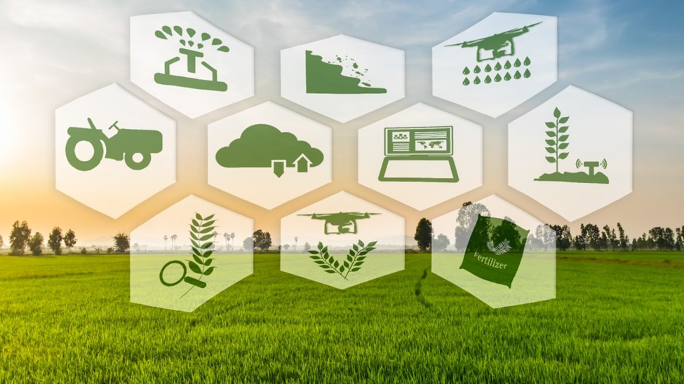

**RESOURCES**

White paper

Roadmap

Investment Agreement

Risk Disclosure

Privacy Policy

Token Sale Agreement

**BLOG**

Articles

News

Events

Videos

**TOKEN SALE**

Agrichainx is an Africa agritech holding developing a blockchain ecosystem that simplifies and streamlines agricultural commodities trade, supply chain, value chain, food security, international collaboration, contracting, logistics, financing and payments for all stakeholder.

Now: Initial Stake Offering/ Equity Fundraising Campaign -700%

**Private sale Tier -50%**

Base price: 1 AGN = $0.5

Discount: 50%

Price including discount: $0.25 = 1 AGN

Minimum contribution: $1000

Maximum contribution: No Limit

Private Sale Tokens being 15,000,000 AGN

Funding Target $3,750,000

Limited participation: 3750 persons

Start date: to be announced

KYC must be passed *

*Citizens or residents of USA, Switzerland, and restricted jurisdictions are not eligible to participate.

**PRE SALE PHASE 1 35%**

Pre-sale will last for a period of four weeks and a maximum of 30 million tokens will be sold during the presale, the funds raised during the pre-sale will be used to take care of operational costs that need satisfying prior to private sale.

Base price: 1 AGN = $0.5

Discount: 35%

Price including discount: $0.325 = 1 AGN

Minimum contribution: $500

Maximum contribution: No Limit

Private Sale Tokens being 15,000,000 AGN

Funding Target $4,875,000

Limited participation: No Limit

Start date: to be announced

**PRE SALE PHASE 2 30%**

Base price: 1 AGN = $0.5

Discount: 30%

Price including discount: $0.35 = 1 AGN

Minimum contribution: $300

Maximum contribution: No Limit

Private Sale Tokens being 15,000,000 AGN

Funding Target $5,250,000

Limited participation: No Limit

Start date: to be announced

MAIN SALE

Base price: 1 AGN = $0.5

Discount: 0%

Price including discount: $0.5 = 1 AGN

Minimum contribution: $25

Maximum contribution: No Limit

Private Sale Tokens being 75,000,000 AGN

Funding Target $37,500,000

Limited participation: No Limit

Start date: to be announced

|  |  |  |  |
| --- | --- | --- | --- |
| **Agricoin Demand** | **Agricoin Supply** | **TGE Overview** | **Roadmap** |

**Agricoin Demand**

Agricoin tokens are required to access, carryout transactions and activate Smart Contracts on agrichainx ecosystem.

|  |  |
| --- | --- |
|  | Agrichainx Token Demand Key Factors  Demand for the services delivered by Agrichainx Blockchain Ecosystem.  Development of a proprietary blockchain.  Growing volume of transactions concluded in Agrichainx tokens.  Crowdfarming and P2P Lending  Insurance coverage and FarmersPension  Expansion of Agrichainx Blockchain Ecosystem by attracting businesses from multiple agric industries and regions. |

**Agricoin supply**

|  |  |
| --- | --- |
| Agricoin Supply  Token Generation Event  The Token Generation Event will be conducted in compliance with KYC/AML regulations. Citizens or residents of USA, Switzerland, and restricted jurisdictions are not eligible to participate in public sale.  The limit on the amount of tokens for sale is set on a per-jurisdiction basis.  **Supply limit:** 200 000 000 agricoin*  **Sale hard cap:** 50 000 000 USD  **Sale soft cap:** 5 000 000 USD | C:\Users\PROVENTIO 03\Desktop\Capturev.PNG |

|  |  |
| --- | --- |
| **TGE Overview**  The Token Generation Event will be conducted in compliance with KYC/AML regulations. Citizens or residents of USA, Switzerland, and restricted jurisdictions are not eligible to participate in public sale.  The limit on the amount of tokens for sale is set on a per-jurisdiction basis.  * The agricoin token is an ERC-20 utility token. When the Proof-of-Use (PoU) mechanism is launched and the proprietary blockchain is developed, the initial ERC-20 tokens may be swapped for tokens of the agrichainx proprietary blockchain. | Symbol AGN  TYPE ERC-20  DECIMAL 18  TOKEN PRICE 1 AGN = $0.5  Accepted Currencies ETH, BTC, NGN  Soft Cap $5,000,000  Hard Cap $50,000,000  TOTAL TOKENS 200,000,000 AGN |

**Roadmap**

Introduction

We believe that the way of progress is development of the technology that is supported and adopted by the society. Agrichainx is not mere technology without users. The Agrichainx products and services is a combination of technological achievements and global networking powered by the community. We are constantly working on the roadmap that reflects our future plans and current progress. Product value creation is not about sticking to a plan, but being able to respond to change.

Roadmap and Equity Fundraising Stages

Please note that the roadmap assumes successful fundraising stage 1 and stage 2 where the max cap is achieved. If the fundraising campaign achieves a different result timeline may be shifted. All the future functionalities are considered actual in the current technological and legal environments.

By the time a certain milestone is reached, some options that are presently planned to follow it may become obsolete or other requirements may arise. Future development plans may have to be adjusted depending on amount of funds raised and the changes in the legal environment, technological environment, and business or other requirements.

**Roadmap**

**Q4: 2018**

Idea Conceptualized

Research and Development

Proving the concept can work

Strategic Plan

**Q1: 2019**

Team Assemble

Whitepaper Development

Awareness Creation and consultation

Preparation for Stake Offering

**Q2: 2019**

Agrichainx Website Launched

Marketing and Initial Stake Offering Begins

Private and Presale Begins

**Q3: 2019**

Main Sale Begins

Launch of Agrichainx ERC20 P2P smart contracts

Internal Exchange Development

**Q4: 2019**

Partnership with major stakeholders.

Alliance with agricultural products processing companies.

Exchange Listing

**Q1: 2020**

Launch of Agrichainx Marketplace

Agrichainx Center Platform development and beta testing begins

**Q2: 2020**

AGNwallet

Launched of Agricfinance

Local Agent Center Launched

**Q3: 2020**

Smart Agric Farming functionality Beta Testing.

AgricCard-Touch and Pay Mobile Solution

AgricPay

**Q4: 2020**

Farmers Pension launched

Launch of Agrichainx mobile app on Google and Apple stores.

IOT Sensor and Monitoring Satellite Deployment.

**Q1: 2021**

Drones acquired for farming and tracking functionality.

Development, launch, and trials of AI and data capturing system prototype.

**Q2: 2021**

Deployment of POC Sensors and initial Data Baseline creation.

Initial data gathering, data scientists start creating control-guide structures. AgricStorage

**Q3: 2021**

Expansion to new markets and global sales.

Agrichainx Equity/ Initial Stake Offering

Crowdfunding Campaign

Invest in Africa’s first ever blockchain agriculture Startup

**Invest**

|  |  |  |  |
| --- | --- | --- | --- |
| MINIMUM INVESTMENT:  N20,000/$60 | INVESTMENT SOUGHT:  $1,200 000 | Start date:  19 Mar 2019 | Accepted Currencies ETH, BTC, NGN |
| VALUATION (PRE‑MONEY):  $1,200 000 EUR | EQUITY OFFERED:  10% | Promotional package:  Free agricoin token |

|  |  |
| --- | --- |
| Introduction  Value Proposition  Use of Funds  Development Strategy and Current Status  Exit Strategy  Promotional Package  Token Sale and Company Valuation  How to Invest  Crowdfunding Campaign Structure  Roadmap | Agrichainx is a blockchain and internet of things ecosystem that simplifies and streamlines agricultural commodities trade, supply chain, value chain, food security, international collaboration, contracting, logistics, financing and payments for all stakeholder. |

agrichainx, the subsidiary of Global Blockchain Innovative Technologies Limited, is developing four flagship products/services:

|  |  |  |  |
| --- | --- | --- | --- |
| **AgricTrade**  An online marketplace connecting agri trade networks from farmers to buyers. | **AgricFinance**  An micro-financing scheme for smallholder farmers. | **AgricHubs**  An enterprise hub that facilitates regional activities taking place inside the agrichainx ecosystem. | **Agricoin**  agrichainx’s institutionalized blockchain-based tokens that is used as a form of payment and settlement between participants. |

Agrichainx combines digital trading, contracting, self-executing smart contracts, financing and embedded payment options in fiat and cryptocurrency, escrow service, and new food supply chain tracking and traceability powered by blockchain technology.

Designed to boost agric business processes, food security and supply chain efficiency, Agrichainx changes the way farmer, consumers, restaurants, super markets, companies do business, rendering traditional business models obsolete.

|  |  |
| --- | --- |
| **Value Proposition**  Agrichainx is an all-in-one solution for agricultural commodities contracting, financing, payments, agric business processes, food security and supply chain efficiency.  Agrichainx combines the functions of farmers, middlemen, brokers, intermediaries, banks, escrow agents, and arbitral institutions.  Agrichainx – a simple solution for complex processes. |  |
|  | **Use of Funds**  At this stage, we are raising funds to develop and release working versions of our core products: agricmart, agricfinance, agrichub, agrichain, agricdata and agricoin.  See roadmap for detailed information on the product development milestones planned after completion of fundraising event.  To date, Agrichainx has been focused on streamlining the company’s processes, on the development of the core products and the ecosystem, and on creating value to its community. |
| **Development Strategy and Current Status**  Our strategic planning process involves a “bottom-up approach” – from unique products with immediate, practical application to a comprehensive blockchain ecosystem.  stage 1  Development of innovative products and the core elements of the ecosystem.  stage 2  Product implementation and integration – practical use and adoption of the blockchain ecosystem.  We are currently in Stage 1 – prototypes and demo-versions of the flagship products have been developed within the framework of the ecosystem development. The next step is the development of the working products. See roadmap for more detailed information. |  |

|  |  |
| --- | --- |
| **Exit Strategy**  It is too early to speculate about detailed exit strategies at this stage.  Agrichainx is yet to achieve ongoing profitability; thus, the success of the venture in the long run is contingent upon further funding. We are building the ecosystem, while simultaneously forging valuable partnerships and obtaining the regulatory authorizations – doing all that is necessary to achieve our vision. Agrichainx is striving to radically change the way companies do business, similar to the way Uber was a disruption to taxi services and Airbnb – to the hotel industry.  We will ultimately require further funding to fully develop and implement Agrichainx Ecosystem and may consider a variety of fundraising sources, including the possibility of an IPO, to secure funding for further expansion. We believe that IPOs for scalable blockchain companies will continue to attract considerable public interest in the coming years. | C:\Users\PROVENTIO 03\Desktop\Capturek.PNG |

|  |  |
| --- | --- |
| **Promotional Package**  Each stakeholder will receive the promotional package; AGN tokens and T-Shirt.  Each participant of the Initial Stake Offering/Crowdfunding campaign is eligible to receive a minimum of 500 free AGN token. For example, a participant who buy a stake during the campaign is eligible to receive 2000 free AGN token.. | C:\Users\PROVENTIO 03\Desktop\Capturel.PNG |
| C:\Users\PROVENTIO 03\Desktop\Capturej.PNG | **Token Sale and Company Valuation**  Should the company valuation be expected to significantly increase as a result of a successful token sale event?  The agricoin token issuance is scheduled for 2019. However, the decision to invest in Agrichainx Initial Stake Offering should be based on the hope that the company valuation will increase as a result of a successful token sale event, adoption, uses case and listing for trading. However, the cryptocurrency market is currently characterized as being at the initial stage of development. And when you have a market that is insufficiently regulated and highly unstable, it is impossible to be certain on any predictions. |

HOW TO INVEST

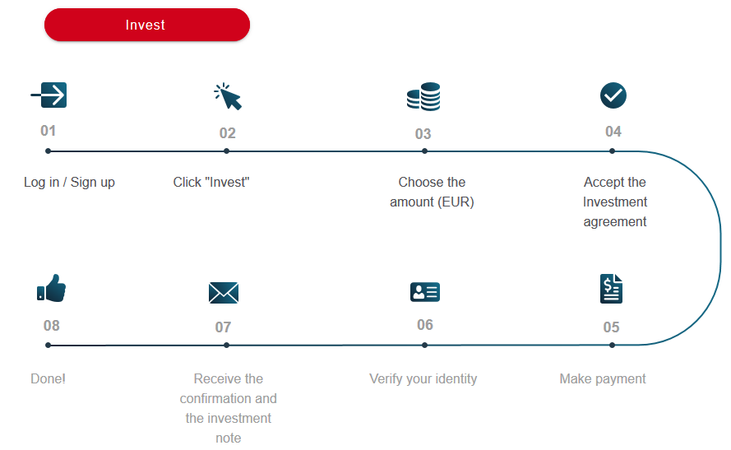

**Crowdfunding Campaign Structure**

Investors make their investment in the shares of the fundraising project – agrichainx – via Global Blockchain Innovative Technologies Limited, which holds their shares on their behalf.

Investors are the beneficial owners of their shares in the fundraising project, but the shares are held on the investors’ behalf by theagrichainx

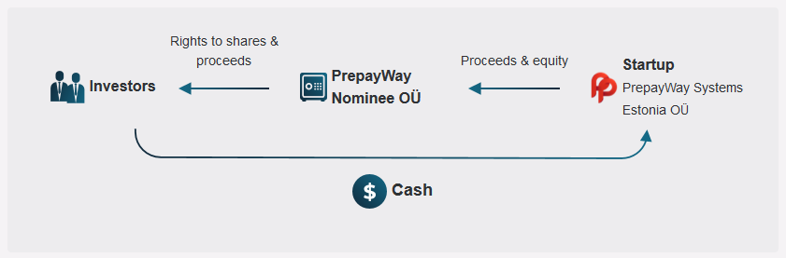

**Future plans**

|  |  |  |
| --- | --- | --- |
|  |  |  |
|  |  |  |
|  |  |  |
|  |  |  |